COVID-19 CRISIS:
OUR RESILIENT CLUBHOUSE COMMUNITIES
Tips & Strategies: Issue #11 | June 15, 2020

We Are Not Alone

Please join us for the next webinar in our series:

Sticking Together:
Utilizing Social Programming to lift our spirits during these tough times

Presented by
Alliance House, Utah
Putman Clubhouse, California

Wednesday June 17, 2020 11:00am (EDT)
Email mailto:WANAWebinar@fountainhouse.org to sign up

Click here for the video recording of ‘Hybrid’ Clubhouse: Integrating traditional onsite Clubhouse with new virtual/remote Clubhouse innovations.

TIPS AND STRATEGIES REGARDING CLUBHOUSES BEGINNING TO RE-OPEN

In our conversations with Clubhouses that have begun the process of re-opening, so far we have learned:

- Most Clubhouses have restrictions on the number of people that can be in the Clubhouse at any time.
- Some have established a system of requiring members to sign up in advance, on a first come first served basis.
- Some have created ‘shifts’ – with some members coming in the morning and some in the afternoon. Some are having members choose a few days per week to come, leaving room for other members on other days.
- Some allow anyone to come but if the building is full when a member arrives, a staff or member will meet with that person outside for a check in.

- Most Clubhouses are continuing with their ‘virtual’ Clubhouse operations – having house and unit meetings online as well as onsite.
- Most Clubhouses have some kind of screening, which can include a temperature check and/or completion of a symptom screening checklist before anyone can enter the building.
- Most Clubhouses have clear and careful systems in place for regularly disinfecting the Clubhouse during the course of the day.
- Computers in use are at least six feet away from each other. Some computers are not being used if they are not within that distance.
- Most Clubhouses are requiring everyone to wear a mask in the Clubhouse, except while eating.
- Lunch
- Some Clubhouses are not serving lunch, but asking people to bring a bagged lunch
- Some Clubhouses are making lunch but asking people to bring the lunch back to their unit where there is more space for distancing.
- Some Clubhouses have arranged the dining room to ensure social distancing, and some have faced all chairs in the same direction to further mitigate face to face contagion.

- Transportation
- Most Clubhouses are discouraging use of public transportation at this time
- Some Clubhouses with vans are limiting number of passengers to ensure safe social distancing.

We will continue to collect and share ideas, plans, and strategies for reopening as Clubhouses continue the process.

Reopening Greetings to the Clubhouse Community, from Clubhouse Lyon, France:

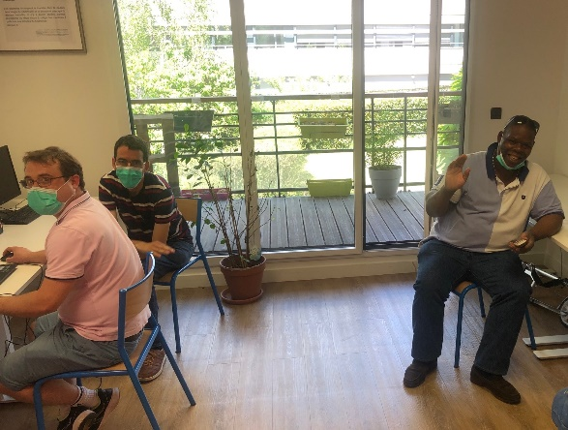
Greetings from Lyon!

We have re-opened the doors on Monday 25th May! Yeah! We planned the re-opening with a few members since the 11th May at the Clubhouse to see how we can manage the work order day. Featured here: our photos of the Clubhouse beginning to reopen!

It’s a slow opening for us as there are still a lot of restrictions post lockdown, though the rules have been relaxed since the 11th May. But it’s good to be back!

We are open 3 afternoons per week for the work ordered day with members who chose which day they wanted to come (and limited numbers so we can respect the social distancing ; 15 members maximum). And each staff has been assigned one afternoon so that the teams don’t mix and meet each other. We have all the hygiene and sanitary measures in place: wearing masks, hydroalcoholic gel in each room, and disinfection at the end of the day of the premises.
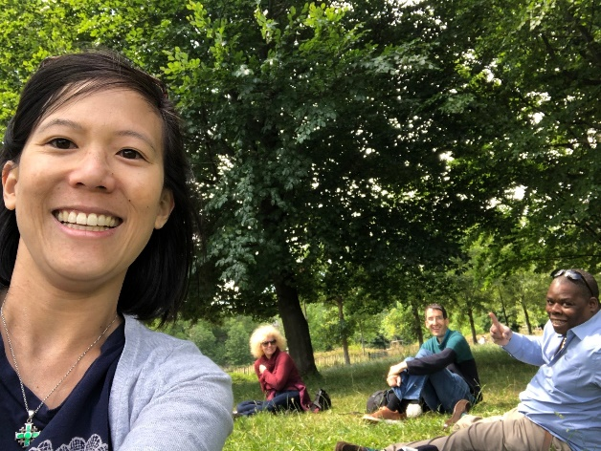
On the other days, we are doing our one on one meetings with members on their projects (especially with those who do not want to come back yet to the Clubhouse with other members for the work order day). Each staff has a specific day/time frame.

We are continuing the online virtual Clubhouse activities via Slack and Zoom such as writing the newsletter, training, cooking classes led by staff, and drawing and qi kong classes led by members. We are continuing the reach out staff to members / members to members each week.

And on other days where we are not at the Clubhouse, the teams meet outside. Since the weather is nice at the moment, one group met yesterday at Parc de la Tête d’Or, had lunch together and then worked on projects for our upcoming fundraising event in October 2020.

We are hoping that the rules will be less restrictive soon so that we can open more hours and with more members!

It’s our 3rd week of re-opening and it’s going along great! Last Tuesday, we worked on 4 different projects in the afternoon. We had to be creative and the work ordered day meeting was held in 2 rooms via Zoom. Members are feeling engaged again and ‘useful’. They are happy to be back with a dynamic program, and see other members. They respect the measures in place and fully understand that for the moment, we organised the work ordered day differently.
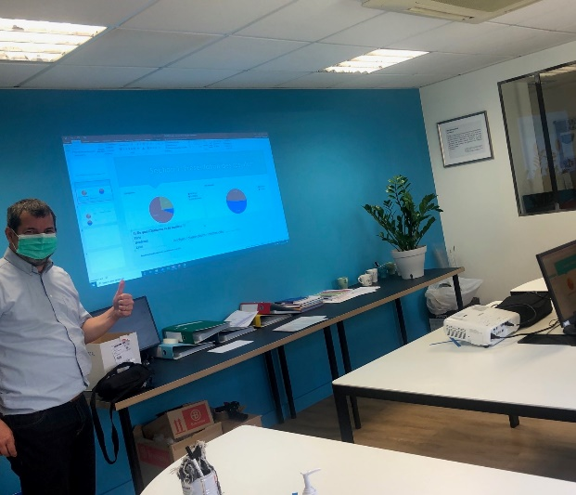
Sharing with you a few photos of the work order day in masks and the working lunch picnic we did on Monday!

Attached is the 2nd newsletter members wrote during the lockdown, and translated by them in English to send to you.

Hope all is well on your end. Keep in touch!

Your friends at Clubhouse Lyon

Click here for the latest Clubhouse Lyon Newsletter!

